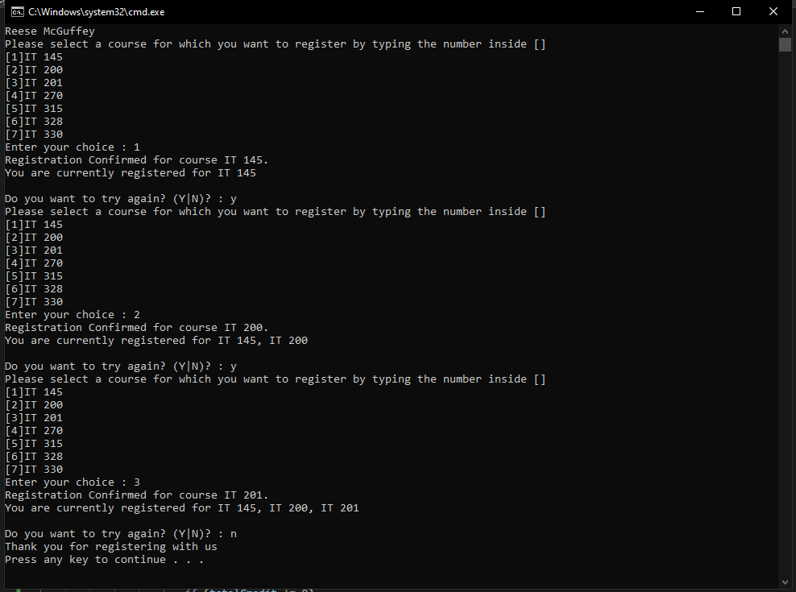

Ideal process for the program, user inputs all the correct choices with no errors. User inputs a number, the number corresponds to the course the user wants to register for. The chosen course is registered and credits hours (3 for each course) are updated accordingly. The user can’t choose more than 3 courses, as it goes over 9 credit hours. Program outputs current registration status and asks the user if they want to continue.

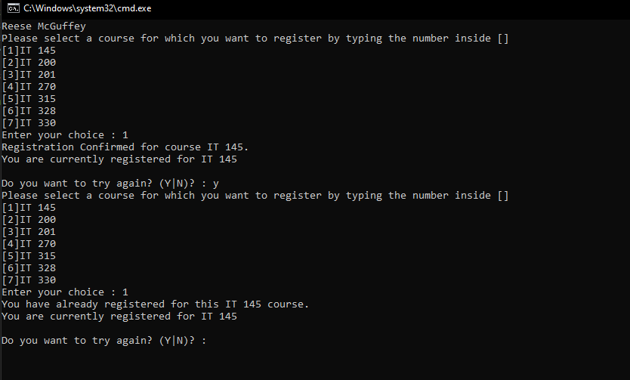

The user cannot input a course they already chose. Credit hours are not updated and the user must choose another course.

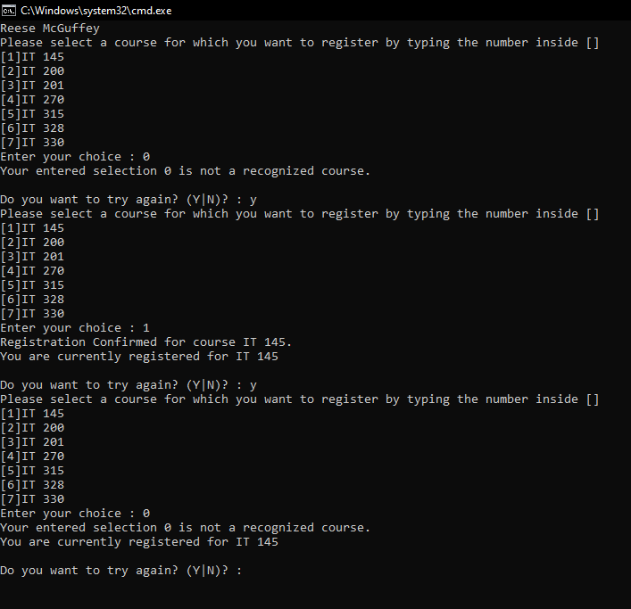

The user cannot input an invalid course. Credit hours are not updated and the user must choose another course. The program also does not display the current registration status if there is an invalid first choice.

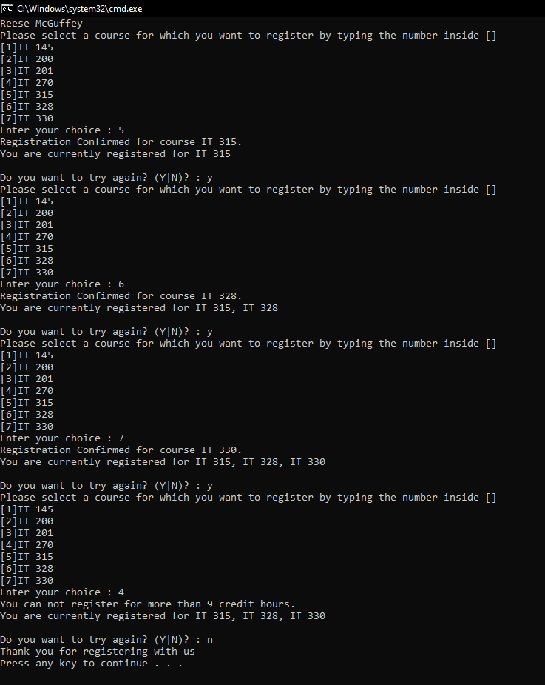

Ideal process, but if the user tries to input another course after the third time, they are unable to. Credit hours are not updated.

using System;

using System.Collections.Generic;

using System.Linq;

using System.Text;

using System.Threading.Tasks;

namespace ConsoleRegisterStudent

{

class Program

{

static void Main(string[] args)

{

(new Program()).run();

}

void run()

{

//declare varibables

int choice;

int firstChoice = 0, secondChoice = 0, thirdChoice = 0;

int totalCredit = 0;

string yesOrNo = "";

System.Console.WriteLine("Reese McGuffey");

//main loop, loops until yesOrNo = N

do

{

//output explanation and convert choice to int

WritePrompt();

choice = Convert.ToInt32(Console.ReadLine());

//check to see if what the user inputted is valid, add course if it is

switch (ValidateChoice(choice, firstChoice, secondChoice, thirdChoice, totalCredit))

{

//if the user inputs an invalid course (ex. 10)

case -1:

Console.WriteLine("Your entered selection {0} is not a recognized course.", choice);

break;

//if the user inputs an already inputted course (ex. 2, then 2 again)

case -2:

Console.WriteLine("You have already registered for this {0} course.", ChoiceToCourse(choice));

break;

//if the user inputs more than three courses

case -3:

Console.WriteLine("You can not register for more than 9 credit hours.");

break;

//if the user inputs a valid course

case 0:

Console.WriteLine("Registration Confirmed for course {0}.", ChoiceToCourse(choice));

//add credit, stop adding if total credit reaches 9

if (totalCredit != 9)

{

totalCredit += 3;

}

//logic to see which choice the user is on

if (firstChoice == 0)

firstChoice = choice;

else if (secondChoice == 0)

secondChoice = choice;

else if (thirdChoice == 0)

thirdChoice = choice;

break;

}

//output current registration status

WriteCurrentRegistration(firstChoice, secondChoice, thirdChoice);

//ask user if they want to continue, program resumes if Y is entered, program stops if N is entered

Console.Write("\nDo you want to try again? (Y|N)? : ");

yesOrNo = (Console.ReadLine()).ToUpper();

} while (yesOrNo == "Y");

//goodbye message

Console.WriteLine("Thank you for registering with us");

}

void WritePrompt()

{

//explanation message

Console.WriteLine("Please select a course for which you want to register by typing the number inside []");

Console.WriteLine("[1]IT 145\n[2]IT 200\n[3]IT 201\n[4]IT 270\n[5]IT 315\n[6]IT 328\n[7]IT 330");

Console.Write("Enter your choice : ");

}

int ValidateChoice(int choice, int firstChoice, int secondChoice, int thirdChoice, int totalCredit)

{

//logic for validating user input

if (choice < 1 || choice > 7)

return -1;

else if (choice == firstChoice || choice == secondChoice || choice == thirdChoice)

return -2;

else if (totalCredit >= 9)

return -3;

return 0;

}

void WriteCurrentRegistration(int firstChoice, int secondChoice, int thirdChoice)

{

//variable output that updates according to which choice the user is currently on, no output if the user makes an invalid input on the first choice

if (firstChoice == 0)

return;

else if (secondChoice == 0)

Console.WriteLine("You are currently registered for {0}", ChoiceToCourse(firstChoice));

else if (thirdChoice == 0)

Console.WriteLine("You are currently registered for {0}, {1}", ChoiceToCourse(firstChoice), ChoiceToCourse(secondChoice));

else

Console.WriteLine("You are currently registered for {0}, {1}, {2}", ChoiceToCourse(firstChoice), ChoiceToCourse(secondChoice), ChoiceToCourse(thirdChoice));

}

string ChoiceToCourse(int choice)

{

//converting the user's number choice to the corresponding course

string course = "";

switch (choice)

{

case 1:

course = "IT 145";

break;

case 2:

course = "IT 200";

break;

case 3:

course = "IT 201";

break;

case 4:

course = "IT 270";

break;

case 5:

course = "IT 315";

break;

case 6:

course = "IT 328";

break;

case 7:

course = "IT 330";

break;

default:

break;

}

return course;

}

}

}